

Modeling and Simulation Project Report

Mohamed Oun - 124897

# Problem 1: The elevator:

## pROBLEM DESCRIPTION

An elevator in a manufacturing can carry exactly 400 kilogram of material. There are three kinds of material, which arrive in boxes of known weight. These materials and their distribution of time between arrivals are as follows:

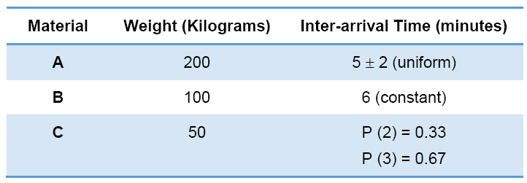

It takes the elevator 1 minute to go up to the second floor, 2 minutes to unload, and 1 minute to return to the first floor. The elevator does not leave the first floor unless it has a full load.

## pROBLEM FORMULATION

The elevator in question is designed to carry materials from one floor to another. It only works if and only its weight reaches a specific amount, namely 400 kilograms, not more, not less.

Each material has its own weight, and its own arrival times, that are dictated by a certain distribution.

Material A has the greatest weight, and arrives in a uniform way every (3-7) minutes. Which means the chance of one arriving after 3 minutes of the last one, is the same as it arriving after 4, 5, 6 or 7 minutes.

Material B has a constant inter-arrival distribution, which means each new one always arrives precisely after that last one by a fixed amount, in this case 6 minutes.

Lastly, each new instance of Material C has a probability of 33% to arrive after the former instance by 2 minutes, and a 67% chance of arriving after it by 3 minutes.

## Objectives

The questions we’d like to answer by simulating this problem is:

* What is the average waiting time for a box of material A, B, and C?

*The average time it takes for a material of type A, B and C to go the top floor, after it arrives.*

* How many boxes of material C made the trip in average each hour?

*The number of material C boxes that went to the top floor each hour.*

* Calculate the percentage of time the elevator was idle.

*The percentage of time in which the elevator is not going up or down.*

## model conceptulization

### Entities:

Elevator, Material A, Material B, Material C, the boxes that are going up, the boxes that are waiting for the elevator to go up and down (boxes that exceed the maximum allowed weight).

### Attributes:

* Weight of Material A, B, and C
* Inter-arrival distribution of Material A, B and C
* Inter-arrival distribution parameters of A, B, and C (start and end of uniform, the number for constant, the probabilities for a probability based distribution)
* The needed weight for the elevator to go up.
* The time it takes the elevator to go up and back down.
* The waiting times for each material type.
* The state of the elevator at each moment (Up or Down)
* Current weight of the queue

### Events:

* Arrival of material A, B or C
* Elevator going up and down

## Experimental design

I ran the simulation for 200 hours as the problem asked, and repeated that 200 times, to get a better representation of the averages, and avoid the chance of noise affecting them. It is the number where the averages started to converge, and stopped fluctuating.

## Results analysis and Conclusion

The results were:

* Average waiting time for A over 200 runs: 6.2 minutes. The minimum waiting time was 5.6 minutes, and the maximum 6.8 minutes.
* Average waiting time for B over 200 runs: 4.8 minutes. The minimum waiting time was 4.4 minutes, and the maximum 5.4 minutes.
* Average waiting time for C over 200 runs: 4 minutes. The minimum waiting time was 3.6 minutes, and the maximum 4.6 minutes.
* The number of boxes of material C that went up each hour was 22 boxes (12 boxes of A, and 12 boxes of B).
* The elevator spent 25% of the time idle, and 75% going up and down.
* Every 200 hours, about 4500 boxes of A, 2000 boxes of B and 2400 boxes of C arrive.

### Waiting times plot:

* When experimenting with a higher minimum weight for the elevator (500 kg), I found that waiting times decreased (5.2 minutes for A, 4.25 for B, 3.5 for C) but the idle time grow to 40% of the time. So depending on which is more expensive, you can prioritize either the waiting times or the idle time.

# Problem 2: The Bearing Failure

## PROBLem description

A large milling machine has three different bearings that fail in service. The distribution function of the life of each bearing is identical, as shown in Table 2.1. When a bearing fails, the mill stops, a repairman is called, and a new bearing is installed. The delay time of the repairman's arriving at the milling machine is also random variable, with the distribution given in Table 2.2. Downtime for the mill is estimated at $10 per minute. The direct on-site cost of the repairman is $30 per hour. It takes 20 minutes to change one bearing, 30 minutes to change two bearings and 40 minutes to change three bearings. The bearing cost $32 each. A proposal has been made to replace all three bearings whenever a bearing fails. Management needs an evaluation of this proposal.

The distribution functions for the lifetimes and delays: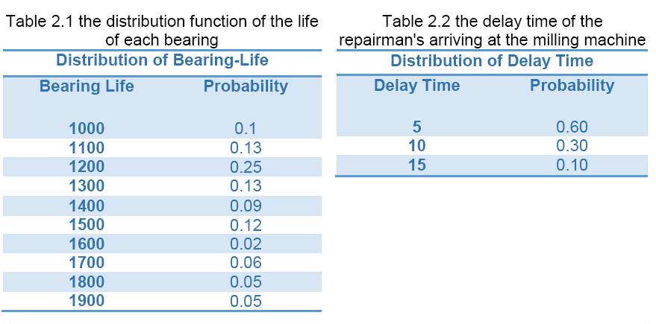

## PROBLEM FORMULATION

A milling machine has three separate bearings, and those bearings often fail in service after a specific shelf time. Each bearing comes with its own shelf time; after which it needs to be replaced. When a bearing fails, the whole machine stops working, until that bearing is replaced, which costs about 10$ for each minute the machine is down. When a bearing fails, a repairman is called, and he arrives after a certain amount of time, which has a distribution function. He starts working on the repair, and takes about 20 minutes to replace the bearing with a new one.

We assume that no two bearings fail at once, as their lifetime is thousands of hours, so the chance is very unlikely.

The repairman charges 30$ per hour, which means 10$ per 20 minutes (the time it takes to replace a bearing).

The proposed alternative system is to replace all the bearings each time a bearing fails. We will test that proposal against the current system, to see if it is more efficient and cost effective.

## Model Conceptualization

### Entities: The 3 bearings.

### Attributes:

* Bearing cost
* Bearing lifetime
* Repairman delay
* Repairman pay
* Time to repair the machine
* Total delay and cost

### Events:

* Bearing failure
* Repairman arrival

## Experimental design

We run the system for 100,000 hours, to get a good number of bearings. We repeat the simulation for 200 times, to remove the noise and streamline the results.

## Results analysis and Conclusion

The results after running the simulation, and calculating the cost of delay until the repairman arrives, plus the cost of delay as he replaces the machines, plus his own pay, and the cost of the bearings themselves.

* We find that the current system costs an average of 0.62$ per hour of service, which means for a run of 100,000 hours, it costs about 62000$, with an average of 225 bearings replaced (per 100,000 hours).
* On the other hand, the proposed system costs us an average of 0.49$ per hour, i.e. 49000$ for each 100,000 hours of service, with an average of 300 bearings replaced (per 100,000 hours).
* We can also see from the graph that in the current system, the cost tends to fluctuate more (minimum cost of 0.57$ per hour, maximum of 0.66$ per hour), because of the increased randomness (We generate more bearings, and the cost depends on the lifetime of each one of them, which are random).
* While the cost in the proposed system is a lot steadier (minimum of 0.48, maximum of 0.5), because we only have 1/3 of the randomness, and we replace all the bearings each time.

*From the results we can conclude that the proposed system is more cost effective, and should replace the current system.*